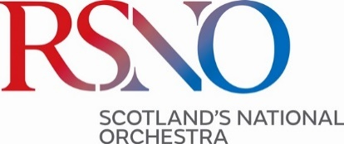

RSNO Youth Chorus Application Form Primary 3, 4 & 5

Please fill in this form and email it to chorus@rsno.org.uk. We will be in touch to arrange a time for your workshop (if required) and to answer any questions you may have.

Deadline for applications: Monday 2 June 2025
Workshops will be held in person on Monday 16 June

Thank you for applying for RSNO Youth Chorus.

Name of child: | Child DOB:
School & school year: | Allergies or medications we should be aware of:
Previous musical experiences (another choir/ drama/singing, instrumental or theory lessons): | Parent / Carer name:
Parent / Carer email: | Parent / Carer phone number:
How did you hear about the RSNO Junior Chorus? | Anything else you think we should know?

